Design Pattern Management Plugin
Software Architecture Document

Version 2.5

Prepared by Hoang Nguyen Nhat Tao

National University of Singapore

8th July 2011

Revision History
Date | Version | Description | Author
18/06/2011 | 1.0 | First Draft | Hoang Nguyen Nhat Tao
25/06/2011 | 2.0 | Revise Logical View  Revise Data View  Add Software Development Plan section | Hoang Nguyen Nhat Tao
08/07/2011 | 2.5 | Revise Software Development Plan  Revise Use-cases  Sketch UI in Use-case Realization  Revise Data View | Hoang Nguyen Nhat Tao  Supervisor: Prof. Stanislaw Jarzabek

Table of Contents
1. Introduction 4
1.1 Purpose 4
1.2 Scope 4
1.3 Definitions, Acronyms, and Abbreviations 4
1.4 References 5
1.5 Overview 5
2. Architectural Representation 5
3. Architectural Goals and Constraints 6
4. Use-Case View 6
4.1 Use-Case Realizations 8
5. Logical View 14
5.1 Overview 14
5.2 Architecturally Significant Design Packages 14
6. Implementation View 15
6.1 Overview 15
6.2 Layers 15
7. Data View (optional) 15
8. Size and Performance 17
9. Quality 17
10. Software Development Plan 17
Software Architecture Document

Introduction

Purpose
This document provides a comprehensive architectural overview of the Design Pattern Management Plugin v1.0, using a number of different architectural views to depict different aspects of the system. It is intended to capture and convey the significant architectural decisions that have been made on the system.

Scope
This Software Architecture Document provides an architectural overview of the Design Pattern Management Plugin. The Design Pattern Management Plugin is being developed by Hoang Nguyen Nhat Tao using C# .NET 4.0 to support the efficient utilization of design patterns in Visual Studio 2010.
The structure of the document is based on the following model views of architecture:
- Use-Case View
- Logical View
- Implementation View
- Data View
This version of Software Architecture Document only focuses on the Use-Case View, Logical View and Data View. The Implementation View will be covered in the next version.

Definitions, Acronyms, and Abbreviations
DPMP = Design Pattern Management Plugin
XVCL = XML-based Variant Configuration Language
MVVM = Model-View-ViewModel
WPF = Window Presentation Foundation
UI = User Interface
VS = Visual Studio
SPC = Software Product Configuration
ORM = Object Relational Mapping

Model-View-ViewModel Pattern
John Gossman (Software Architect at Microsoft for Windows Presentation Foundation and Silverlight technologies) introduced the Model View ViewModel (MVVM) pattern in 2005. An MVVM application consists of three major components: the Model, the View and the ViewModel:
- Model: the set of entities representing business concepts
- View: the set of graphical controls for displaying Model data on the screen
- ViewModel: contain UI logic, commands, events and reference to Model. View observes ViewModel and
updates itself whenever ViewModel changes
More information about MVVM Pattern can be found from the references.

Repository Pattern
Repository Pattern is used to separate the logic that retrieves data and maps it to the entity model from the business logic acting on the model. It queries the data source for data, maps the data to the business entity and persists changes in the business entity to the data source. More information about MVVM Pattern can be found from the references.

References
1. (n.d.). Retrieved from XML- Based Variant Configuration Language - Technology for Reuse: http://xvcl.comp.nus.edu.sg/overview_technical_a.php
2. (n.d.). Retrieved from Microsoft .NET Framework 4.0: http://www.microsoft.com/downloads/en/details.aspx?familyid=9cfb2d51-5ff4-4491-b0e5-b386f32c0992
3. Arvind, G. (2010). Reuse and Maintainace of Design Pattern Code using XVCL - B.Comp.Dissertation. National University of Singapore.
4. Example: Software Architecture Document. (n.d.). Retrieved from http://www.ts.mah.se/RUP/wyliecollegeexample/courseregistrationproject/artifacts/analysisndesign/sadoc.htm
5. (2011). Introduction to Model View ViewModel and Line of Business Applications. In R. Garofalo, Building Enterprise Applications with WPF and the MVVM (pp. 1-23). Microsoft Press.
6. MDSN. (n.d.). Retrieved from ADO.NET Entity Framework: http://msdn.microsoft.com/en-us/library/bb399572.aspx
7. Software Architecture Document. (n.d.). Retrieved from http://www.medbiq.org/std_specs/techguidelines/softwarearchitecture.pdf
8. Qazi, K., Mikalainis, P., Warang, R., & Virk, S. Software Architecture Document Swapping Skillz n'
Thingz 1.0 Traderz Unlimited Team 2.
9. Veeneman, D. (n.d.). Using the Microsoft Desktop Stack – Part 3: Using Entity Framework 4 in an MVVM Application. Retrieved from http://www.codeproject.com/KB/WPF/MSDesktopStack3.aspx
10. The Repository Pattern. (n.d.). Retrieved from http://msdn.microsoft.com/en-us/library/ff649690.aspx

Overview
The rest of the Software Architecture Document contains the following subsections documenting various aspects of the architecture:
- Section 2: describe the purpose and intention of each view in the architecture
- Section 3: describe the architectural goals and constraints of DPMP
- Section 4: describe essential functionalities and how they are realized in the architecture
- Section 5: describe how the system is structured from a logical and high-level point of view
- Section 6: describe the implementation details of each component in DPMP
- Section 7: describe the data storage perspective of DPMP
- Section 8: describe all the issues related to the performance of DPMP
- Section 9: describe all the aspects related to the quality of service attributes

Section 6, 8, 9 are not applicable in this version of Software Architecture Document.

Architectural Representation
This section gives the description of each view in the architecture of DPMP. Although this version of Software Architecture Document only covers User-Case View, Logical View and Data View, it is worth overviewing all views to understand different aspects of software architecture.
- Use-Case View:
- Audience: stakeholders and end-users of the system
- Purpose: describe a set of scenarios representing essential functionalities of the system and
corresponding actors involved in each scenario.
- Artifacts: UML Use Case, GUI Prototype
- Logical View:
- Audience: designers
- Purpose: present the overall structure of the system with layers and components
- Artifacts: UML Components Diagram
- Implementation View:
- Audience: developers
- Purpose: describe in details the layers and components of the system
- Artifacts: UML Activity Diagram, UML Sequence Diagram, UML Class Diagram
- Data View:
- Audience: database administrators
- Purpose: describe data elements and their relationship in the data model
- Artifacts: Database Model Diagram

Architectural Goals and Constraints
This section describes the software requirements and objectives that have significant impacts on the architecture.

Dependency
DPMP calls XVCL Java processor to generate design pattern instances. The XVCL Java processor version 3.2.3 can be downloaded at http://sourceforge.net/projects/fxvcl/files/

Distribution
DPMP is delivered in Visual Studio Extension Package. DPMP utilizes SQL Server Compact 4.0 as the database engine. Since it is portable, user can use one design pattern database in different computers.

Design and Implementation Strategy
- DPMP follows MVVM Pattern as the architecture pattern, which is described in Section 1.3.
- DPMP has its user interface built on WPF 4.0.
- DPMP utilizes Microsoft SQL Server Compact Edition 4.0 as the database engine.
- DPMP applies ADO.NET Entity Framework 4.0 and Repository Patterns for data access.
- DPMP is written in Microsoft C# .NET 4.0.

Development Tools
- Microsoft Visual Studio 2010 Ultimate Edition
- Microsoft Expression Blend 4

Operating System Requirements
- Window XP SP3 or newer
- Microsoft .NET Framework 4.0
- Java Runtime Environment (JRE) 1.6

Use-Case View
This section lists use cases or scenarios representing essential functionalities of DPMP. Below are the use cases with significant impact on the architecture:
Use Case 1: Add new design pattern instance
System: DPMP
Actors: User
Preconditions: None
Main Success Scenario:
1. User chooses to add new design pattern instance.
2. DPMP asks for instance name, pattern type and locations.
3. User specifies instance name, pattern type and locations.
4. DPMP creates and displays the new instance.
Extensions:
3a. An instance of the same name and same pattern type already exists.
3a1. DPMP informs user of invalid instance.
Use case continues from step 2.

Use Case 2: Add design pattern instance to specific locations
System: DPMP
Actors: User
Preconditions: Some pattern instance already exists
Main Success Scenario:
1. User chooses a pattern instance to add.
2. DPMP asks user to select locations.
3. User specifies locations.
4. DPMP creates pattern instances in specified locations.

Use Case 3: Remove design pattern instance
System: DPMP
Actors: User
Preconditions: Some pattern instance already exists
Main Success Scenario:
1. User chooses a design pattern instance to remove.
2. DPMP asks user for confirmation.
3. User confirms to remove the pattern instance.
4. DPMP removes pattern instances from related locations.

Use Case 4: Rename Design Pattern Instance
System: DPMP
Actors: User
Preconditions: Some pattern instance already exists
Main Success Scenario:
1. User chooses a design pattern instance to rename.
2. DPMP asks user for new name.
3. User enters new name for the pattern instance.
4. DPMP propagates changes to related locations and displays the renamed pattern instance.
Extensions:
3a. An instance of the same name and same type already exists.
3a1. DPMP informs user of invalid instance renaming.
Use case continues from step 2.

Use Case 5: Edit Design Pattern Instance
System: DPMP
Actors: User
Preconditions: Some pattern instance already exists
Main Success Scenario:
1. User chooses a design pattern instance to edit.
2. DPMP displays the instance content.
3. User modifies the instance content and saves it.
4. DPMP propagates instance changes to related locations.

Use-Case Realizations
Use cases can be realized through the UI Prototype. DPMP contains seven main windows:
- Pattern Explorer
- Pattern Properties
- Pattern Locations
- Add New Instance
- Pattern Designer
- Pattern Code Editor
- Output/Error List

Pattern Explorer
This window has two main components: Button Bar and Pattern Tree Viewer.

Button Bar contains the following buttons:
- Add: open up Add New Instance window for user to add new design pattern instance
- Show Current/Show All: show pattern instances of the current project or show all pattern instances
- Refresh: synchronize the Pattern Tree Viewer with the database
- Generate All: generate and populate all design pattern instances to specified locations

Pattern Tree Viewer displays all the created pattern instances and groups them under corresponding pattern models.

Clicking Show Current button displays pattern instances of the current project (Figure 1)
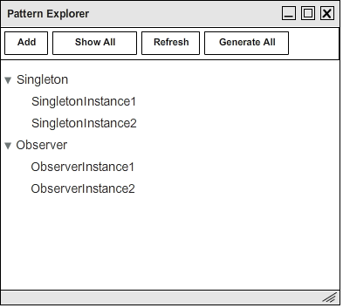
Figure 1: Show pattern instances of the current project

Then clicking Show All button displays all created pattern instances (Figure 2)

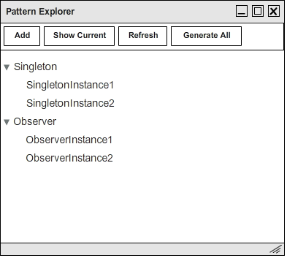
Figure 2: Show all created pattern instances

When user right-clicks on a pattern model, a context menu will pop up and show the following commands: (Figure 3)
- New Instance: open up Add New Instance window for user to add new design pattern instance
- Generate All: generate and populate all pattern instances of the selected pattern model to specified
locations

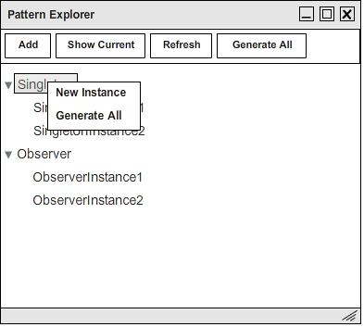
Figure 3: Right-click on a design pattern model
When user right-clicks on a pattern instance, a context menu will pop up and show the following commands: (Figure 4)
- View Designer: open up Pattern Designer window for user to see the visual representation of the
selected pattern instance
- View Code: open up Pattern Code Editor window for user to see the behind code of the selected
pattern instance
- Add to…: user can either add the selected pattern instance to the current project (Current Project) or
select a specific location to add to (Other). Add to Other opens up Select Folder dialog for user to
specify the location.
- Generate: Generate and populate the selected pattern instance to specified locations
- Remove: open up Pattern Locations window for user to choose from which locations the pattern
instance will be permanently removed
- Rename: rename the selected pattern instance
- Properties: open up Pattern Properties window for user to see the properties of the selected pattern
instance

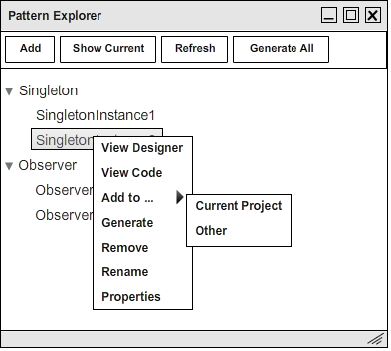
Figure 4: Right-click on a design pattern instance

Pattern Properties
This window shows three properties of each pattern instance: (Figure 5)
- Instance Name: name of the pattern instance, editable
- Pattern Type: type of the pattern instance, e.g. Singleton, Observer, Adapter, etc., editable
- Locations: collections of locations to which the pattern instance will be populated. View button opens
up Pattern Locations window for user to add/remove/edit all locations of the pattern instance.

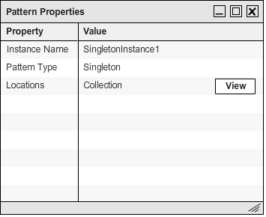
Figure 5: Properties of a design pattern instance

Pattern Locations
This window lists all the locations to which a design pattern instance will be populated (Figure 6).
- Add button allows user to add new location to the list.
- Remove button allows user to remove selected locations from the list.
- Select All button allows user to select all the locations in the list for further actions.
- Refresh button synchronizes the UI with the database.

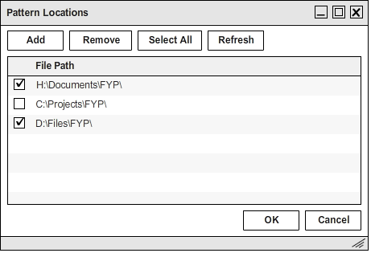
Figure 6: Locations of a design pattern instance

Add New Instance
This window asks user to specify details of new design pattern instance: (Figure 7)
- Instance Name: name of the pattern instance
- Pattern Type: type of the pattern instance, e.g. Singleton, Observer, Adapter, etc.
- Locations: collections of locations to which the pattern instance will be populated. Add button opens
up Pattern Locations window for user to add new location of the pattern instance.

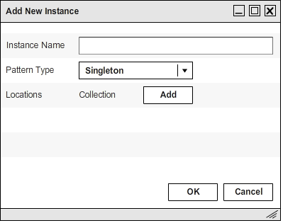
Figure 7: Add new design pattern instance

Pattern Designer
This window allows user to see and edit pattern instance based on its visual representation (Figure 8). It contains two parts:
- Using: allow user to add/remove .NET libraries used in the pattern code
- Class: show all components/classes inside the pattern instance and the relationships between them.
There are customizable parts inside each components/classes such as private field name, methods, etc.
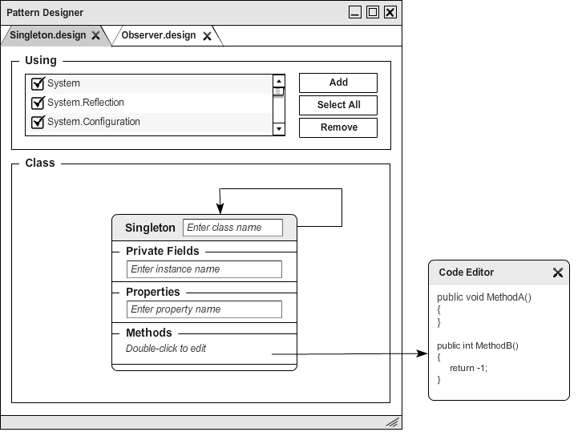
Figure 8: Add new design pattern instance
Pattern Code Editor
This window displays the behind code of a design pattern instance. It shows the X-Frame code side-by-side with the SPC code. User can edit the pattern instance by editing the SPC code. X-Frame code is non-editable. (Figure 9)
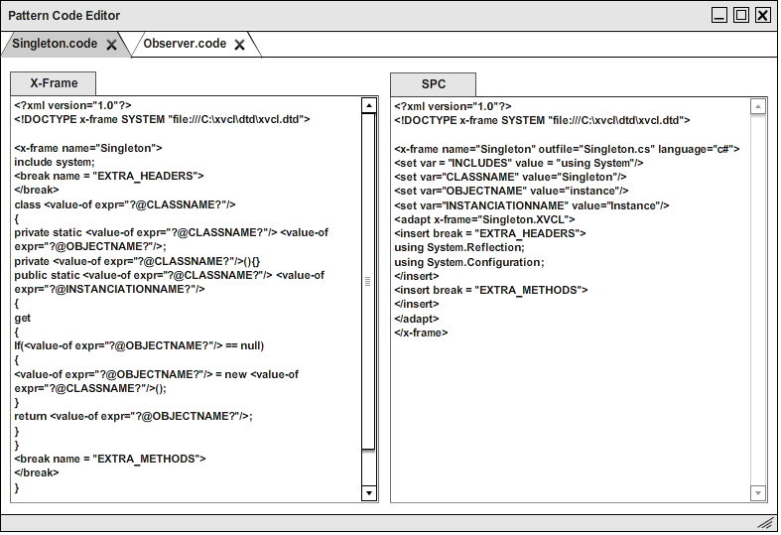
Figure 9: Add new design pattern instance

Output/Error List
The Output window summarizes the result of the pattern instance generation. If there is any error during the pattern generation, the Error List window will capture the details of errors for user to debug.

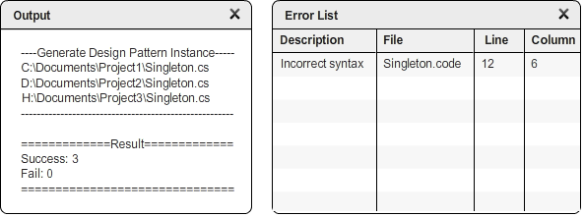
Figure 10: Add new design pattern instance

Logical View

Overview
DPMP is designed based on the MVVM and Repository Patterns. More details about MVVM and Repository Patterns are provided in Section 1.3. The following diagram (modified from Veeneman in his article) describes the overall decomposition of DPMP in terms of packages and components:

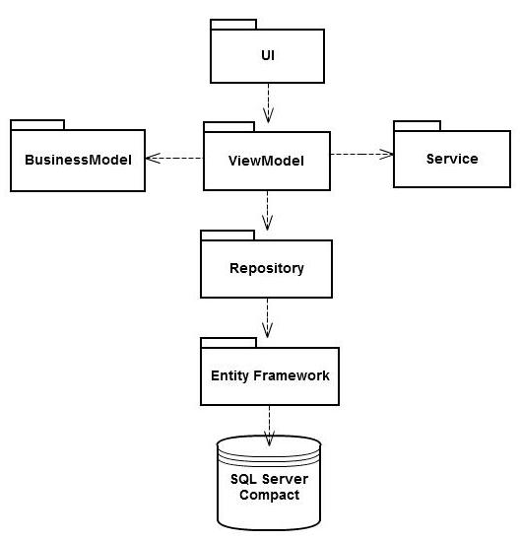

Architecturally Significant Design Packages
- UI (View): DPMP windows, graphical controls, only communicate with ViewModel. Controls in View
are data-bound to properties in ViewModel.

- ViewModel: coordinator between UI (View) and the other components in DPMP. ViewModel delegates
the majority of its work to its sub-components Command, Service and Event.
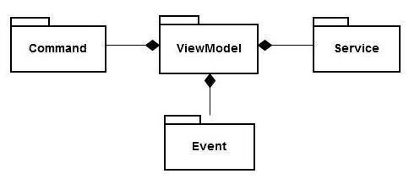

- BusinessModel: consist of ADO.NET Entity Framework change-tracking objects. Objects are not
passed to Repository each time they are modified because ADO.NET Entity Framework monitors the
changes and updates the data as soon as the data context is saved.

- Services: contains helper classes performing common tasks. This Service component is different from
the Service sub-component of ViewModel, which performs tasks specific for ViewModel.

- Repository: interface for data access, encapsulating ADO.NET Entity Framework. Hence, other
components need to know nothing about ADO.NET Entity Framework.

- ADO.NET Entity Framework: act as the ORM mechanism for DPMP
- SQL Server Compact Data: DPMP’s data storage

Implementation View
This section is not applicable in this version.

Overview
This section is not applicable in this version.

Layers
This section is not applicable in this version.

Data View (optional)
This section describes the persistent data storage perspective of DPMP.

Entity Relational Diagram

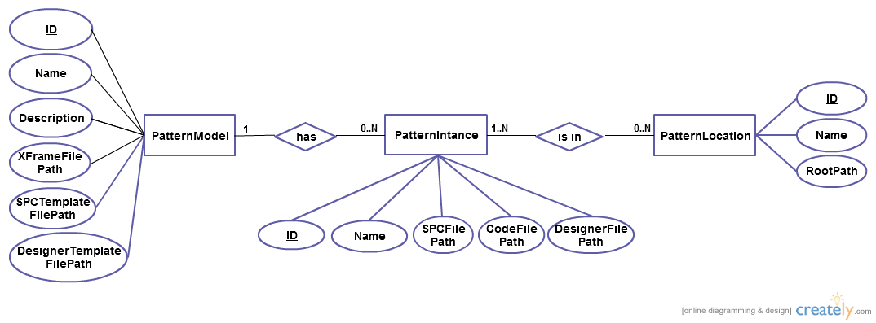

Relational Schema

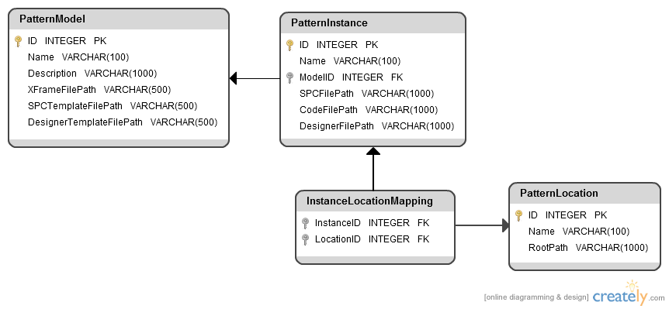

Tables:
- PatternModel: details about a design pattern model
      - ID: primary key, identify the design pattern model, required field
      - Name: name of the design pattern model to be displayed, required field
      - Description: describe the design pattern model, not required
      - XFrameFilePath: path to the XFrame file of the design pattern model, required field
      - SPCTemplateFilePath: path to the SPC Template file of the design pattern model, required field
      - DesignerTemplateFilePath: path to the Designer Template file of the pattern model, required field
- PatternInstance: details about a design pattern instance
      - ID: primary key, identify the design pattern instance, required field
      - ModelID: foreign key, ID of the corresponding design pattern model, required field
      - Name: name of the design pattern instance to be displayed, required field
      - SPCFilePath: path to the SPC file of the design pattern instance, required field
      - CodeFilePath: path to the Code file of the design pattern instance, required field
      - DesignerFilePath: path to the Designer file of the design pattern instance, required field
- InstanceLocationMapping: mapping records between pattern locations and design pattern instances
      - InstanceID: primary and foreign key, ID of corresponding design pattern instance, required field
      - LocationID: primary and foreign key, ID of corresponding location, required field
- PatternLocation: details about a pattern location
      - ID: primary key, identify the location, required field
      - Name: name of the location, not required
      - RootPath: path to the root directory of the location, required field, unique

Relations:
- PatternInstance.ModelID references PatternModel.ID
- InstanceLocationMapping.InstanceID references PatternInstance.ID
- InstanceLocationMapping.LocationID references Location.ID

Size and Performance
This section is not applicable in this version.

Quality
This section is not applicable in this version.

Software Development Plan
Task No | Type of Task | Task Description | Task Status
1 | Main Task | Specify Software Requirements | Done
2 | Main Task | Design Software Architecture | Done
3 | Main Task | Finalize Features for the 1st release | Done
4 | Main Task | Sketch UI layouts and components | Done
5 | Main Task | Build Entity Data Model (Business Model) | In Progress
6 | Main Task | Generate Database From the Entity Data Model
7 | Main Task | Implement Repository component
7.1 | Sub Task | Implement IRepository interface
7.2 | Sub Task | Implement Repository base class
7.3 | Sub Task | Implement Repository classes for entities
8 | Main Task | Unit-test Repository component
9 | Main Task | Implement ViewModel component
9.1 | Sub Task | Implement View Models based on the UI design
9.2 | Sub Task | Implement Commands to realize use-cases
9.3 | Sub Task | Implement Events
10 | Main Task | Unit-test ViewModel component
11 | Main Task | Implement UI layout and graphical components
12 | Main Task | Integrate UI component and ViewModel component through data binding
13 | Main Task | Integration-test DPMP
14 | Main Task | Enhance DPMP by adding more advanced features and improving the look-and-feel

